EXPT NO:13 ROLL NO: 220701209

INSTALL AND CONFIGURE IPTABLES FIREWALL

**Aim:**

To install iptables and configure it for a variety of options.

Common Configurations &amp; outputs:

**1. Start/stop/restart firewalls**

[root@localhost ~]# systemctl start firewalld

[root@localhost ~]# systemctl restart firewalld

[root@localhost ~]# systemctl stop firewalld

[root@localhost ~]#

**2. Check all exitstingIPtables Firewall Rules**

[root@localhost ~]# iptables -L -n -v

[root@localhost ~]#

**3. Block specific IP Address(eg. 172.16.8.10) in IPtables Firewall**

[root@localhost ~]# iptables -A INPUT -s 172.16.8.10 -j DROP

[root@localhost ~]#

**4. Block specifig port on IPtables Firewall**

[root@localhost ~]# iptables -A OUTPUT -p tcp --dport xxx -j DROP

[root@localhost ~]#

**5. Allow specific network range on particular port on iptables**

[root@localhost ~]# iptables -A OUTPUT -p tcp -d 172.16.8.0/24 --dport xxx -j ACCEPT

[root@localhost ~]#

**6. Block Facebook on IPTables**

[root@localhost ~]# host facebook.com

facebook.com has address 157.240.24.35

facebook.com has IPv6 address 2a03:2880:f10c:283:face:b00c:0:25de

facebook.com mail is handled by 10 smtpin.vvv.facebook.com.

**7. Whois**

[root@localhost ~]# whois 157.240.24.35 | grep CIDR

CIDR: 157.240.0.0/16

[root@localhost ~]#

[root@localhost ~]# whois 157.240.24.35 [Querying whois.arin.net] [whois.arin.net]

#

# ARIN WHOIS data and services are subject to the

Terms of Use # available at:

https://www.arin.net/resources/registry/whois/tou/ #

# If you see inaccuracies in the results, please report at

#

https://www.arin.net/resources/registry/whois/inaccuracy_repo

rting/ #

# Copyright 1997-2019, American Registry for Internet

Numbers, Ltd. #

NetRange: 157.240.0.0 - 157.240.255.255 CIDR: 157.240.0.0/16

NetName: THEFA-3 NetHandle: NET-157-240-0-0-1

Parent: NET157 (NET-157-0-0-0-0)

NetType: Direct Assignment OriginAS:

Organization: Facebook, Inc. (THEFA-3) RegDate: 2015-05-14

Updated: 2015-05-14

Ref: https://rdap.arin.net/registry/ip/157.240.0.0

OrgName: Facebook, Inc. OrgId: THEFA-3

Address: 1601

Willow Rd. City: Menlo Park StateProv: CA

PostalCode: 94025

Country: US

RegDate: 2004-08-11

Updated: 2012-04-17

Ref: https://rdap.arin.net/registry/entity/THEFA-3

OrgTechHandle: OPERA82-ARIN

OrgTechName: Operations

OrgTechPhone: +1-650-543-4800

OrgTechEmail: domain@facebook.com

OrgTechRef: https://rdap.arin.net/registry/entity/OPERA82-ARIN

OrgAbuseHandle: OPERA82-ARIN

OrgAbuseName: Operations

OrgAbusePhone: +1-650-543-4800

OrgAbuseEmail: domain@facebook.com

OrgAbuseRef: https://rdap.arin.net/registry/entity/OPERA82-ARIN

#

# ARIN WHOIS data and services are subject to the Terms of Use

# available at: https://www.arin.net/resources/registry/whois/tou/#

# If you see inaccuracies in the results, please report at

# https://www.arin.net/resources/registry/whois/inaccuracy_reporting/ #

# Copyright 1997-2019, American Registry for Internet Numbers, Ltd. #

[root@localhost ~]# iptables -A OUTPUT -p tcp -d 157.240.0.0/16 -j DROP

Open browser and check whether http://facebook.com is accessible

To allow facebook use -D instead of -A option

[root@localhost ~]# iptables -D OUTPUT -p tcp -d 157.240.0.0/16 -j DROP

[root@localhost ~]#

**8. Block Access to your system from specific MAC Address(say 0F:22:1E:00:02:30)**

[root@localhost ~]# iptables -A INPUT -m mac --mac-source 0F:22:1E:00:02:30 -j DROP

[root@localhost ~]#

**9. Save IPtables rules to a file**

[root@localhost ~]# iptables-save &gt; ~/iptables.rules

[root@localhost ~]# viiptables.rules

[root@localhost ~]#

**10. Restrict number of concurrent connections to a Server(Here restrict to 3 connections only)**

[root@localhost ~]# iptables -A INPUT -p tcp --syn --dport 22 -m connlimit --connlimit-above 3 -j REJECT

**11. Disable outgoing mails through IPtables**

[root@localhost ~]# iptables -A OUTPUT -p tcp --dport 25 -j REJECT

[root@localhost ~]#

**12. Flush IPtables Firewall chains or rules**

[root@localhost ~]# iptables -F

[root@localhost ~]#

**OUTPUT:**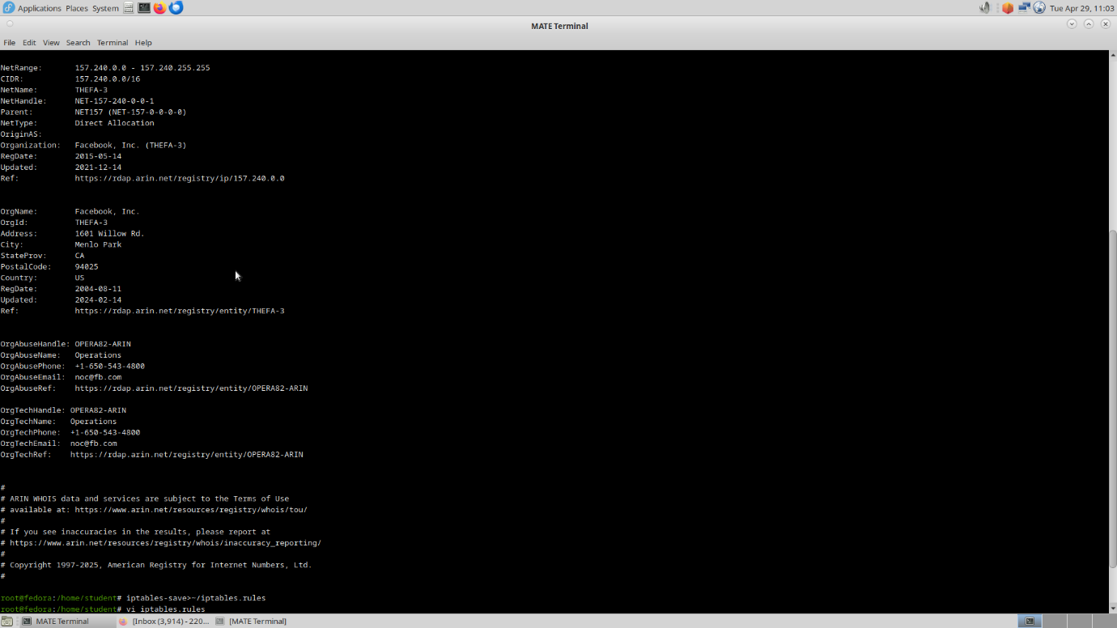

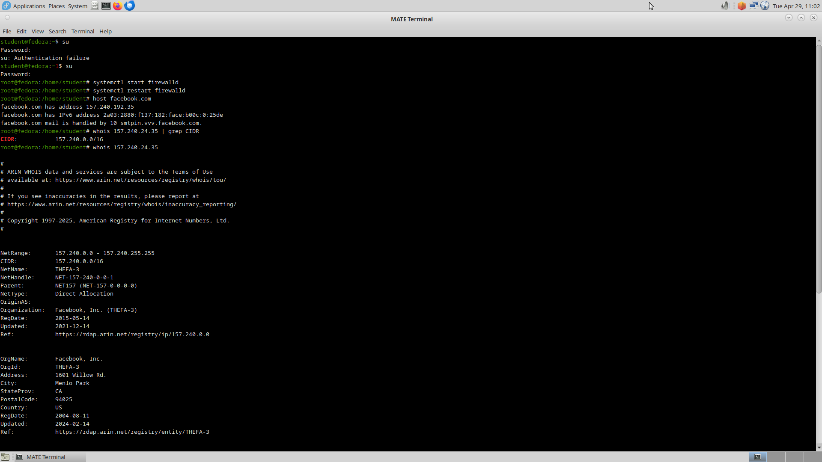

**RESULT:**

To install and configure iptables and firewall is executed successfully.